# Commercial Data request Shiny app

An app written in R and Shiny to process data files output from QGIS to filter and format data for a commercial data request. The app replicates the functionality in the Commercial Restrictions Macro.

There are options:

* To specify the CSV file containing the data
* Whether to output Protected & Notable or All species
* Whether to delete records at a specified radius from a given grid ref.
* Whether to highlight sensitive species (e.g. for EIA or woodland grant requests)
* Which optional designations to remove ( or place on the Other species tab)

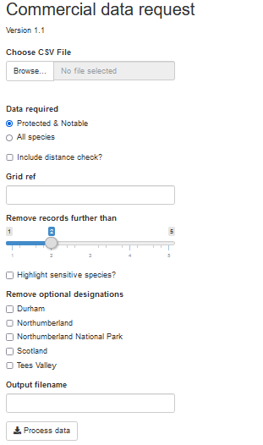

## Output

* An Excel spreadsheet containing one or more tabs depending on the selection made. Some fields may be highlighted if there is data that needs to be checked before sending to the client.

## Online location

Accessed at https://ericnortheast.shinyapps.io/DataRequestProc/

## Code overview

The code makes extensive use of the ERIC_Data_Proc data processing library developed in R.

* Get input parameters
* Read the data from the input file
* Format the date field
* Remove data that we don’t want from specific surveys:
  + All CDBC records
  + Northumbrian Water Violet Crystalwort records
  + Tom Tam’s Bedstraw Hawk-moth records at Holy Island
* Remove records from the “Great Crested Newt License Returns “ survey with zero abundance
* Merge location columns
* Update labels, survey names, etc.
  + For EA surveys "River Jelly Lichen 2005", "White-Clawed Crayfish 2005", "Pale Bristle-Moss & Spruce's Bristle-Moss 2006" and "Orange-Fruited Elm-Lichen 2005" & the species is one of the ones surveyed for ("Collema dichotomum", "Austropotamobius pallipes", "Thotrichum pallens","Thotrichum sprucei" "Caloplaca luteoalba"):
    - Blank out location
    - Obscure grid ref
    - Add note about contacting EA
  + For planning/misc surveys blank out the survey run by field
  + For Terry Coult surveys blank out the survey name field
  + Remove any references to “Terry Coult” in the recorder or survey run by field
  + For the RSNE survey set the recorder field to RSNE
  + For the North Pennines AONB remove references to “farm” in the location or “(farmer)” in the recorder field
  + For the Butterfly Conservation survey:
    - Set the recorder field to “Butterfly Conservation”
    - If the species is one of Grayling, Large Heath, Small Pearl-bordered Fritillary or Northern Brown Argus blank out the location and add a note about contacting Butterfly conservation
  + For the National Bat Monitoring survey add a note linking to the metadata document on the ERIC website
  + For the “Batsites Inventory for England 1949 - 2011” and “Natural England Bat Worker Records” surveys add the NE copyright notice
* Fix designations by adding text to the All designations field:
  + For species in the specified lists for local BAPs (Northumberland, Durham and Tees Valley) add text denoting the appropriate local BAP
  + Where the appropriate field is set add text relating to WACA Sch 9 Part 1 or 2
  + Add the text “Designation not provided” for:
    - For all amphibians except “Mesotriton alpestris”
    - For specific species ("Arvicola","Lutra","Meles" and "Sciurus")
    - For specific groups ("fish, jawless (Agnatha)" , "marine mammal" and "reptile")
  + Add the text “Waxcap grassland indicator” for the waxcap species "Hygrocybe", "Entoloma", "Clavaria", "Microglossum", "Geoglossum", "Dermoloma", "Porpoloma", "Camarophyllopsis", "Clavulinopsis", "Ramariopsis", "Trichoglossum", "Glutinoglossum", "Cuphophyllus", "Porpolomopsis", "Neohygrocybe", "Gliophorus", "Gloioxanthomyces", "Hodophilus" and "Pseudotricholoma"
* Calculate eastings and northings
* If specified remove records outside given radius
* For the protected and notable species
  + Get the data
  + Format it and check for:
    - House numbers in location
    - Zero abundances
    - Swear words in comments
    - E-mail addresses in comments or recorder name
  + If specified flag species on the ERIC sensitive species list
  + Write it to an Excel tab highlighting any fields as necessary
* If specified
  + Get the remaining data
  + Format it and check as above
  + If specified flag species on the ERIC sensitive species list
  + Write it to a second Excel tab highlighting any fields as necessary
* Save the Excel spreadsheet, asking the user for the name and location

Anne Donnelly – 20/07/22